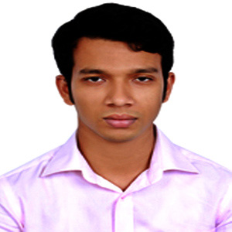
RESUME

Md. Mehedi Hasan
Contact & Address:
Mirpur-13, Dhaka
E-mail: mahedishihab07@gmail.com
Mobile No: 01671-048286

Career Objective

Looking for hard and Challenging Job where I will have the scope of utilizing my potentiality, adaptability and skill to do something innovative and from where I will be able to enhance my knowledge.

Professional Experiences:

- Junior Programmer (January 2024 to untill)
Smart Code Bangladesh Ltd
House No: 783, Road No: 11,
Avenue: 3, Mirpur DOHS,
Dhaka-1206, Bangladesh
Web: www.smartcodebd.com

- Junior Programmer (January 2023 to 2024)
IGNITE TECHNOLOGY
Chuti, 315/2, Road No. 8,
Madrasha Road, East Kazipara,
Mirpur, Dhaka-1216
Web: www. ignitetechno.com

Academic Profile
Master’s of Arts (M.A)
Institution | : | Dhaka University
Result Obtained | : | CGPA 3.31
Bachelor of Arts (B.A)
Institution | : | Dhaka University
Result Obtained | : | CGPA 3.53
Higher Secondary Certificate (HSC)
Institution | : | Madhupur Shahid Smrity High School
Group | : | Humanities
Education Board | : | Dhaka
Result Obtained | : | GPA 4.60 in a scale of 5
Year of Passing | : | 2009
Secondary School Certificate (SSC)
Institution | : | Madhupur Shahid Smrity High School
Group | : | Humanities
Education Board | : | Dhaka
Result Obtained | : | GPA 4.75 in a scale of 5
Year of Passing | : | 2007

Special Qualification

- Work well under pressure and in strict deadline as well as a team or a leader
- Responsible, efficient and flexible in working environment.
- Quick learner
- Strong analytical ability
- Self-motivated

Language Proficiency

Fluent communication Skill on the both speaking and writing in English and Bengali.

Computer Skills

I have a good working Knowledge in Ms-Word, Ms- Excel, Ms- PowerPoint, E-Mail and Internet Browsing etc.

Interest

Reading books, Traveling, Games and Sports, Watching movies and Listening music etc.

Skills:

Computer Knowledge:
- Programming Language: HTML, CSS, Bootstrap5,
Java script, PHP, Laravel.
- Database Language: SQL Server 2000/2005/2008/2012,mySQL,PostGre SQL.
- Able to computer hardware troubleshooting.
- Able to setup LAN (Basic).

Operating System Known:
- Windows 10, Ubuntu 14.10 LTD, Mac OS (Catalina).

Personal Information

Name | : | Md. Mehedi Hasan
Father's Name | : | Md. Shamsul Haque
Mother's Name | : | Momtaj Begum
Date of Birth | : | 15-02-1992
Gender | : | Male
Marital Status | : | Unmarried
Nationality | : | Bangladeshi
Religion | : | Islam
Permanent Address | : | Vill: Tangry, P.O: Madhupur, P.S: Madhupur, Dist: Tangail

Reference

CM Mehedi Hasan Mohammad Saiful Islam
Team Lead Web developer
ITDSC, Dhaka Mirpur, Dhaka
Mob: 01711972985 Mob:01814957460

Declaration

I do hereby declare and certify that all the information stated above is true and complete to the best of my knowledge.

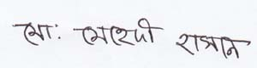
…………………….
Signatur
Md. Mehedi Hasan

